# About a Binary Tree itself and a quiz about it（Episode Quiz & Information）

'**Author：Iam Rougamo**

**Co-Author & Advisor：FengLing**

### INTRODUCTION AND QUIZ

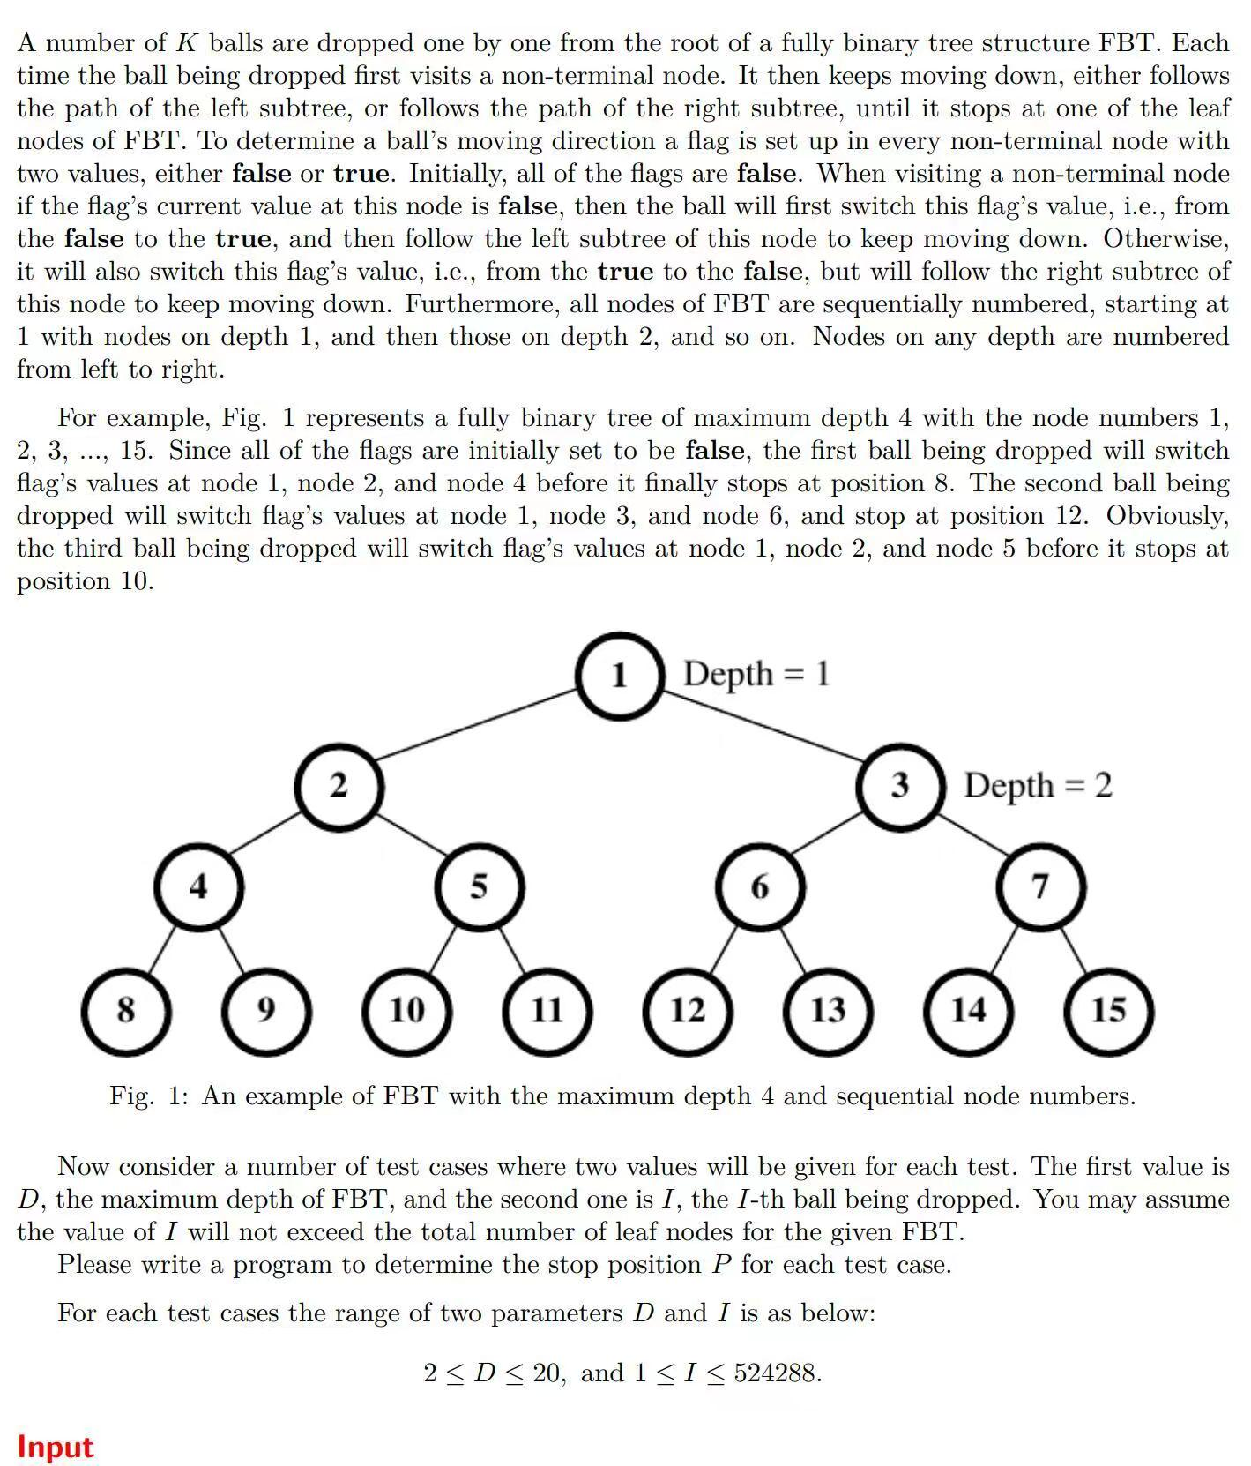

## Let me start by saying that computer science and math are inseparable. That's why we chose to put this question in the math club. Computer science requires knowledge of L**inear Algebra**, C**ombinatorial Mathmatics,** N**umber Theory** ,**Graph Theory**, **Set Theory**, and a variety of other things. Obviously, we are more likely to find such talent in The math club that focus on math researching.

## But of course, the main of the series is to popularize the basic knowledge of **Trees**(a kind of graph), and how we can use the simplest undersatnding of the concept to complete the above complex-looking Problem(This part will be discussed in another blog).

## Trees and Binary Trees

### The concept of *Tree*

### **Set n as the number of nodes.**

### The "graph" we see in the question above is something called a ***tree***, while I'm used to calling it a ***Tree Diagram*** (and I think there're more than me who calls it that).

### The mathematical definition of a ***Tree*** is a bit confusing: it's a ***finite set*** of n ***nodes***, so a tree is a set (which sounded pretty nonsense). Well, since sets can contain empty sets, it is also logical to suppose that we have ***empty trees***. ***A*** ***tree with no node is called an empty tree***.

### The case where **n≠0**, which is a ***non-empty tree,*** has some of the following **properties**:

### One and **ONLY ONE** node is the ***Root Node.***

### When **n>1**,the rest of the nodes can be divided into m ***non-intersecting* finite sets N1, N2, N3......Nm**,each set is in turn a tree and is called a ***subtree of the tree***.

### Tree is a ***recursive structure*** with ***self-similarity,*** which is used in the definition of itself.

### A tree as a ***hierarchical logical structure*** has the following properties:

### The root node of the tree has no ***Predecessors,*** and all nodes other than the root node have one and only node as their Predecessor. (All sons have the same father)

### A node in a tree may have many ***Descendants***, one descendant, or no descendants (a father may have multiple sons).

### ***n-node tree has n-1 edges.***

### Basic terms for trees

1. Consider a node M, from the root node A to node M has a ***unique path***, all the nodes experienced is called the ***Ancestors*** of M, if node B is an ancestor of node M, then node M is called an ***Offspring*** of B. The ***Closest Ancestor*** of node M, name it node K, is called the ***Parent*** of node M,and node M is called the ***Child*** of node K. **The root node A is the only node that has no parents**. Two nodes with the same parents are called ***Brothers***.
2. The number of children of a node in a tree is called ***The Degree of the Node***, and the largest degree of all nodes in the tree is called ***The Degree of the Tree***.
3. Define the degree value ***ξ***. if ***ξ*** > 0,the node is called a ***Branch node*** . If ***ξ*** = 0, the node is called a ***Leaf node.***
4. Hierarchy of nodes: Defined from the root node of the tree, the root node is ***Level 1***, its child nodes as ***Level 2*** and so on. Nodes that stay in the same level are called ***Cousins***.
5. ***The depth of a node*** is cumulation from the top to the bottom and ***the height of a node*** is cumulative from bottom to top.
6. The depth (height) of a tree is the ***maximum number of levels of nodes*** in the tree.
7. ***Ordinal*** and ***Non-sequential*** Trees: A tree in which the nodes are ordered from left to right and cannot be exchanged is called an ***Ordered tree.*** The opposite is an ***Unordered tree***.
8. ***Path*** and ***Path Sequence***: All the ***edges*** from the root node to the node are called the ***Path,*** the number of edges called the ***Path Length***.
9. An ordered tree with a degree of 2 at each node is called a ***Binary Tree***.